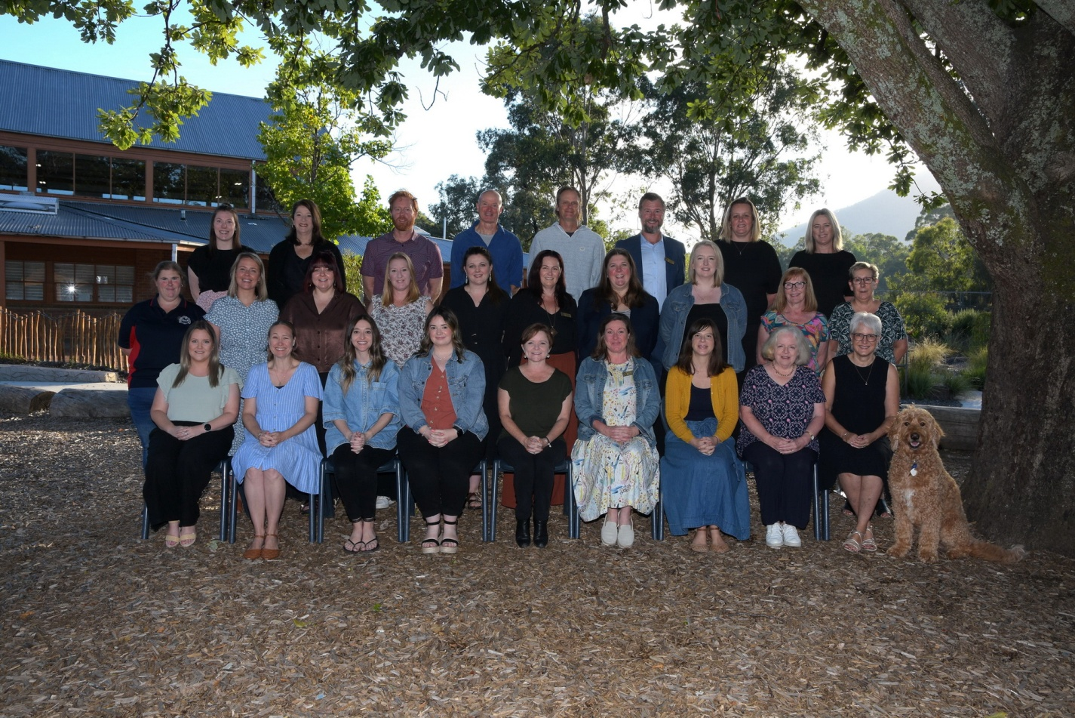
Row 3 L-R: Taylah Mazzella, Julia Hulland, Andrew Moore, Sean O'Neil, Jason Congreve, Scott Crawford, Emma Griffiths, Lissa Prasel
Row 2 L-R: Ash Wheelen, Lucy Bissels, Sarah Hubbard, Kaisey Hart, Megan Pepprell, Alyssa Stephens, Nerae Preece, Keylie Groen, Elisabeth Klavers, Janet Miller
Row 1 L-R: Shantelle Bellingham, Belinda Granger, Marissa Carpenter, Kasey Marra, Ellen D'Alterio, Kathryn Douglas, Vanessa Imberger, Sally Calvert,
Meralyn Hammond, Cooper
Principal: Scott Crawford
Absent: Brogan Smith, Stephanie Connell, Meaghan Carter, Sarah Round, Elizabeth Cadzow, Danielle Bullas, Angela Swindle School Staff 2025

